Malware Infection Investigation

Joe McIvor
CMP416: Advanced Digital Forensics
2025/26

Note that Information contained in this document is for educational purposes.

Executive Summary

This report below covers an in-depth investigation on an infected network caused by an exploited malware sample on multiple devices all linked to each other communicating to one another from an attacker to gain access and credentials from the victim machine. The investigation followed a strict methodical process highlighting identifying network traffic, analysing a systems memory, system and browser logs to finally identifying what the indicators of compromise were. The findings from the report investigation where that the PC-491 machine had tried exploiting the victim machine Workstation-758 by conducting a spoofing technique allowing devices to be tricked in to honing the harmful software. The end result was that Workstation’s credentials where stolen beaconed out back to the attacker and stored in a file being prepared for a ransom payment. The report has confirmed that the university’s perimeter firewall isn’t fit for purpose, these known techniques for applying malicious intent should have been alerted and remedied much earlier to prevent the whole internal network being compromised. The following recommendations can be implemented : Implementing a high level Network intrusion detection System(NIDS) or implementing a Host based intrusion detection system(HIDPS).Limitations of the paper include improper clear analysis of the firewall and browser logs this limits the analysis of the browser history of the devices meaning the malware may have harvested more from the urls however the analysis carried out did not explore this fully.

Contents
1 Investigative Plan 1
1.1 Overview of Plan 1
1.2 Ensuring Legal and Procedural Compliance 2
2 Performing Analysis 4
2.1 Traffic exploration 4
2.2 Memory forensics 7
3 Interpret and report findings 31
3.1 Timeline of events & affected devices 31
3.2 How the malware spread 31
3.3 Challenges during analysis 32
4 Recommendations 33
4.1 Remediation and prevention plan 33
References 34
Appendices 35
Appendix A 35
Appendix B 38

Tools Used
Wireshark v4.4.6(Wireshark,Unknown)-Wireshark is an insdutsty standard open source tool that speicialises in digital forensics specifically network forensics.The tool is widely known for being one of the most prestigiois and most pwoerful tools out in industry.Wireshark will be used for analysing the pcap file in the infected host network, reconstructing communications, investigation connections and suspicous querys.

Evtxparserv0.9.0(omerbenaram,2025)–EVtx parser is known parser for transferring a .evtx file in to .json for it to be accessed within a linux environemetn.The parser will be used in the investigation below to transfer the devices system logs from windows format to json.
Kali Linux Virtual Machine v2025.2- A specific linux machine that provides an acting operating system virtual machine that allows users to create a sandbox environment for testing.This will machine will be used below for analysing the infected network.

Md5sumv9.7.2-md5sum is a hash algorithm that gives a file or directory a unqiue long code that can only be replicated by an exact copy.Md5hash will be used in the data preservation stage of the report investigation by helping to comply to the ACPO principles being all orginal data must be kept preserved.

Volatility3v2.27.0(Volatility3,2025)–This tool specialises in digital forensics examinations, its an opensource based tool that can be used on multiple operating systems. Its main usage is for analysing RAM or virtual memory dumps.Volatility3 will be used in the investigation to recover forensic information from the memory dump, the tool is industry standard practice for conducting forensic examinations.

MemprocFs v5.16(Ufrisk,2025)- An open-source framework that forensically analyses a RAM sample or a virtual memory dump in a thorough forensic manner. The tool is compatible with numerous operating systems and for the investigation below will be used in a Linux environment. This tool will be used below in comparison to Volatility3 when approaching the network communication sector in Section 3 of the forensic methodology.

Investigative Plan

Overview of Plan
The content below will demonstrate how the investigation will take place with a specific forensic methodology that is suitable for investigating malware infections in a network environment. Due to the nature of malware, all evidence will be analysed within a Kali Linux VM.

- Identifying network traffic on the infected host
- Open up the .pcap file within Wireshark to view the capture.
- Identify how many packets captured overall, establish a scope.
- Click on the “statistics” tab then “conversations” to get a clear communication.Reconstruct TCP streams from the communications.
- Filter the .pcap file to DNS to explore suspicious queries.
- Take note of timestamps on DNS/TCP activity for futher down in the report(IOC’s).
- Analysing the systems memory
- Download MemProcFS Linux edition and Volatility 3 framework drag them in to the VM.
- Turn of the Kali machine and turn of both settings for “guest isolation” turn the VM back on.
- Extract the MemProcFS within each “memory” directory of each device and create a copy of the memory.bin file.
- Hash the files to make sure they are a direct copy of the evidence ensuring preservation.
- Drag the copy in to the MemprocFS Enter forensic mode and mount the results to an empty location on the machine.
- Do this processes for every device, view what contents the tool has found relating to processes and network connections for every device.
- Use Volatility 3 for suspicious processes to carve deeper information on behavior intention and check for code injection attemtps.
- Analysing the system logs and browser logs.
- Download and drag in the evtx parser to the VM, then for every device drag this in to the “logs” directory.
- Use the evtx parser to turn the files in to JSON,go through the Powershell.json and Security.json files in each device to identify malware usage and times of occurrence.
- Check device malware folders if malware deployments have been successfully carried out.
- Indicators of Compromise.
- Lastly check browser history export for any IOC’s such as high network traffic
- Check suspicious device links or outsources between devices that may raise caution.

Ensuring Legal and Procedural Compliance

ACPO PRINCIPLES
The following investigation will adhere to the ACPO principles below to demonstrate appropriate practice in the scenario where the results from the investigation can be used in court of law. The following ACPO principles are exactly from (forensic control, No date) showing below :

- No action must be taken that will change data held on a digital device that could later be relied on as evidence in Court.
- If it’s necessary to access original data held on a digital device, you must be both competent to do so and able to explain your actions, as well as explain the impact of them on any digital evidence used in a Court.
- A trail or record of all the actions taken and applied to the digital evidence must be created and kept safely and securely. If an independent third party forensic expert examines the processes they should be able to come to the exact same conclusion.
- The person in charge of the investigation has the overall responsibility of making sure these principles are followed.

Chain of Custody Form (NIST,2025)

Description of Evidence
Item # | Quantity | Description of Item (Model, Serial #, Condition, Marks, Scratches)
1 | 1 | A packet capture file of Network Traffic from the infected host network.
2 | 1 | A memory image of the systems.
3 | 1 | System logs of the firewall.
4 | 1 | An export of browser history from the workstations.

Chain of Custody
Item # | Date/Time | Released by  (Signature & ID#) | Received by  (Signature & ID#) | Comments/Location
1 | 19/11/2025  9:00 am | S.Sturley | Joe McIvor  2202055 | University
2 | 19/11/2025  9:00 am | S.Sturley | Joe McIvor  2202055 | University
3 | 19/11/2025  9:00 am | S.Sturley | Joe McIvor | University
4 | 19/11/2025  9:00 am | S.Sturley | Joe McIvor | University

Performing Analysis

Traffic exploration
Tools used – Wireshark
Step 1.1 Download the investigation materials, drag this in to a virtual machine like Kali Linux and extract the contents.
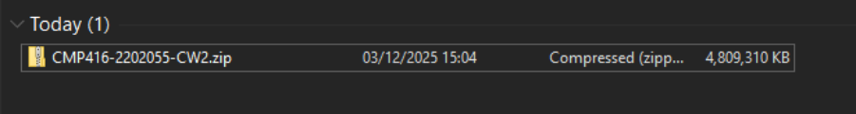
Figure 1 Investigation materials
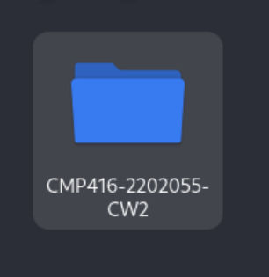
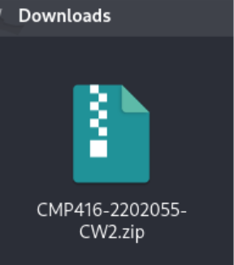

Figure 3 & 4 Extract the contents

Step1.2 Look through the materials to establish a baseline of evidence, Open scenario_info.json to identify what devices are on the network establishing a baseline.
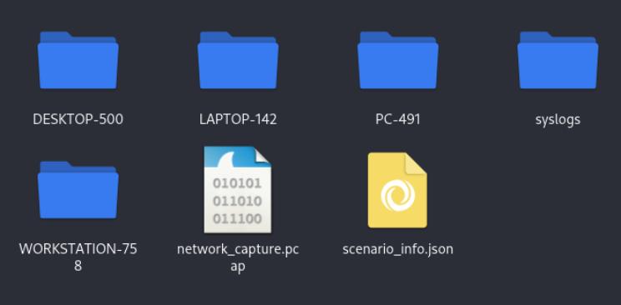

Figure 5 Materials from the infection

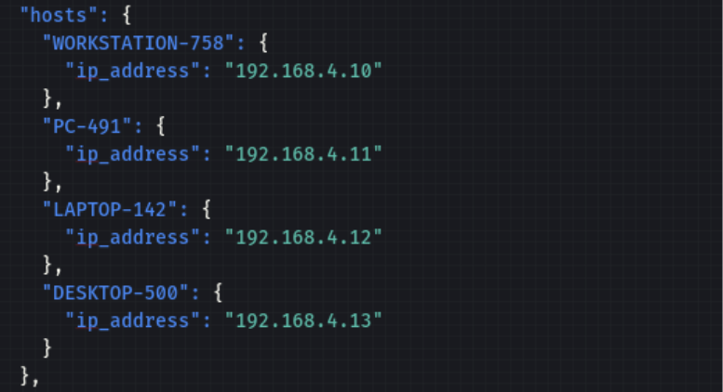

Figure 6 Devices on the network

Step1.4 Open the .pcap in Wireshark and Click on the “statistics” then “conversations” to view the conversations that took place on the network.
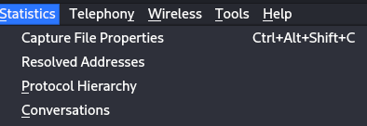

Figure 7 Conversation filter

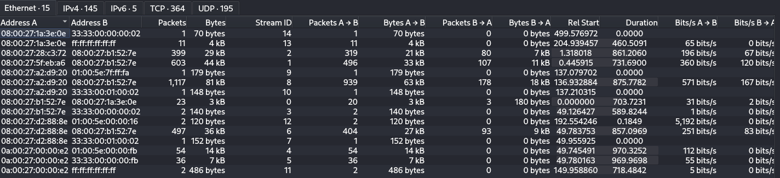 Figure 8 145 IPv4 connections on the network

Step1.5 Filter that .pcap file to only view the DNS queries, take not of any suspicious queries.
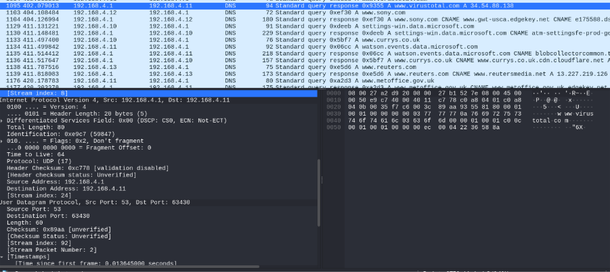
Figure 9 DNS query to Virustotal
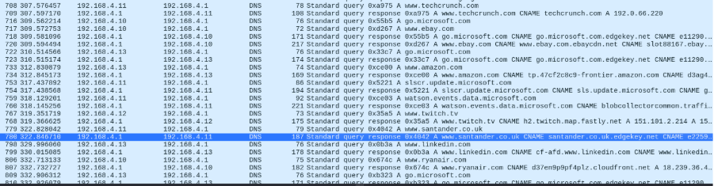
Figure 10 DNS query to Santander

Results-Overall Wireshark was an excellent option for analysis, the above Figure9 shows a screenshot of a suspicious DNS query to an application called Virustotal. Virustotal is an application that can identify and determine the severity of different types of malwares. It can bring up details regarding the name of the harmful software and what its intention is. Figure10 shows DNS query’s to multiple popular applications including the financial sector with the query to Santander. This highlights suspicious query's as from the .pcap file we can see that PC-491(192.168.4.11) is trying to access websites possibly hinting to a carrier of malicious intent. This can also be said for LAPTOP-142(192.168.4.12).

Memory forensics
Tools used - MemProcFS & Volaitility3

Preparing memory forensics
Downloading the materials
Dragging them in to the VM
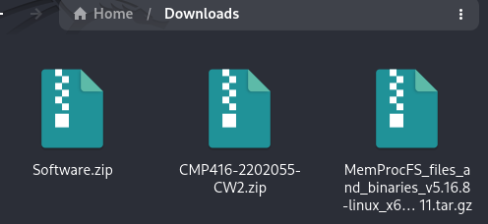

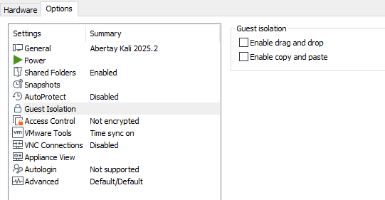
Turning of guest isolation and extracting the material
Step 2.1 Make a copy of the of the memory for PC-491 making sure the data isn’t being altered, adhering to the procedural and legal compliance of ACPO 1.
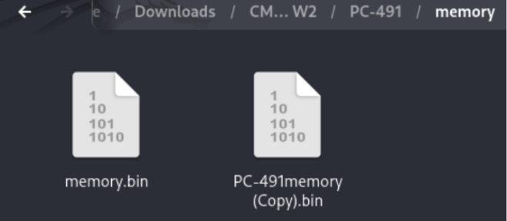

Figure 8 Copy of memory
Step2.3 First extract the MemprocFS in to the PC-491 “memory” folder,put the copy of the memory in to the MemprocFS directory.

Figure 9 Copy of the original

Step2.4 To confirm reliability of results, check the hash using md5sum of both the original and copy to ensure the preserved copy is an exact replica of the initial memory.
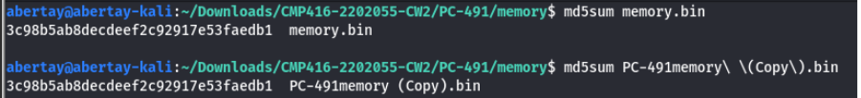 Figure 10 Exact duplicate of original evidence

Step2.5 Open a terminal within the MemprocFS folder, Select the memory to be analysed and enter the forensic mode(1) to analyse the memory.Mount the results in an empty directory.
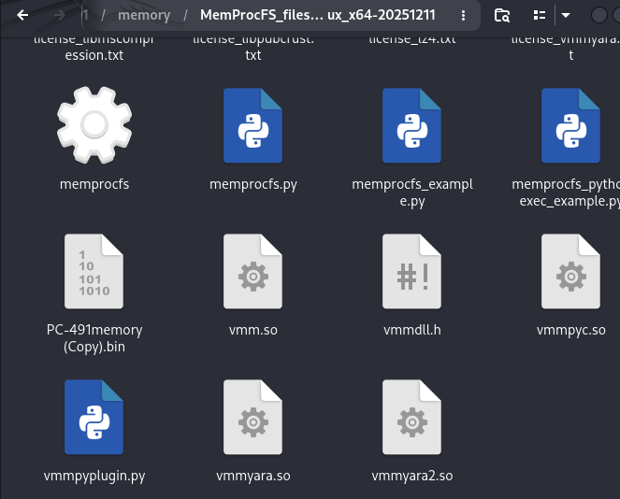
Figure11 PC-491 Memory ready
Step2.5 View the mounted memory dump on the pictures directory and explore PC-491’s memory.

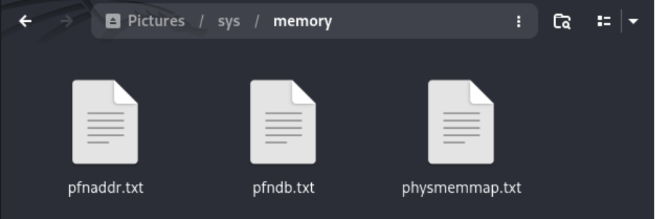

Figures 12 & 13 Memproc has created 3 .txt file

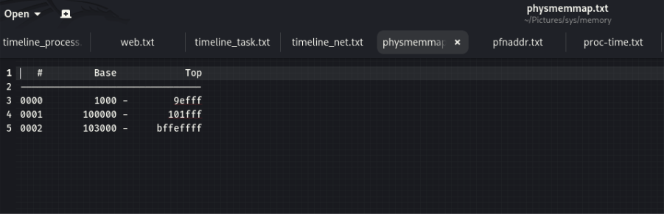
Figure 14 PC-491 physical memory

Step2.6 Repeat these exact steps for the Desktop, Laptop and Workstation on the network to spot abnormities within the machines memory, running process and network connections.
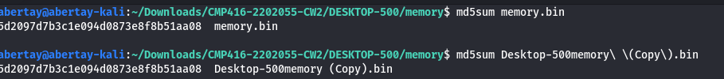
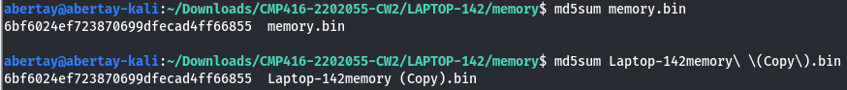
Figures 15 Every device memory duplicated
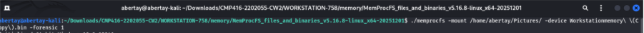
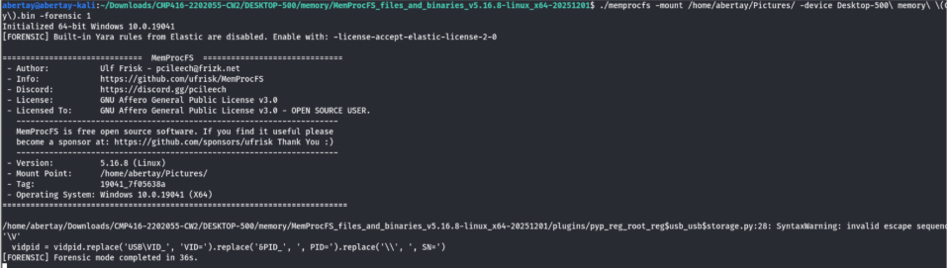
Figure 16 Extracting the memory of every device

Highlights processes results(Appendix A for more):
Desktop500- lssas executable used for authentication and generating user tokens.
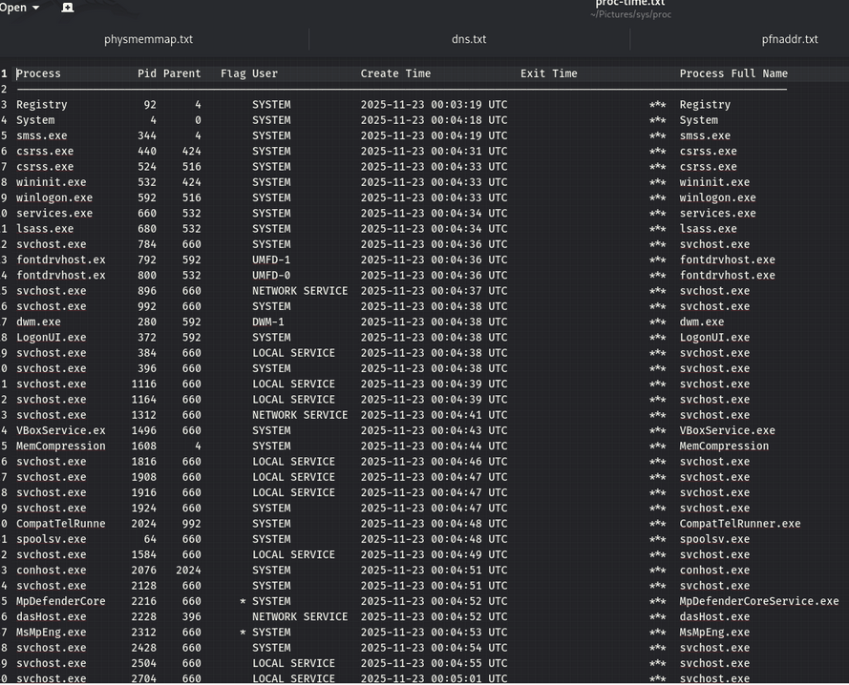
Figure 17 lssas executable process ran
Laptop-142 - Powershell usage, LogonUI executable used for accessing user domains.
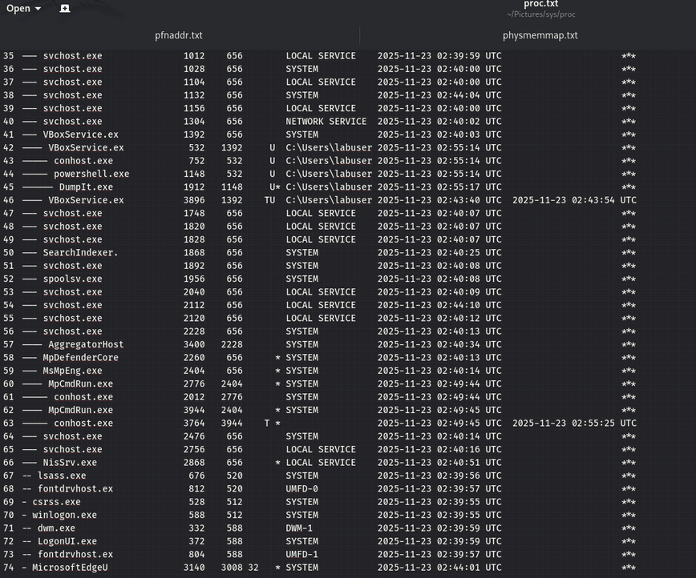
Figure 18 Powershell and LogonUI present

Workstation-758 Microsoft defender and MsMpg being attacked repeatedly
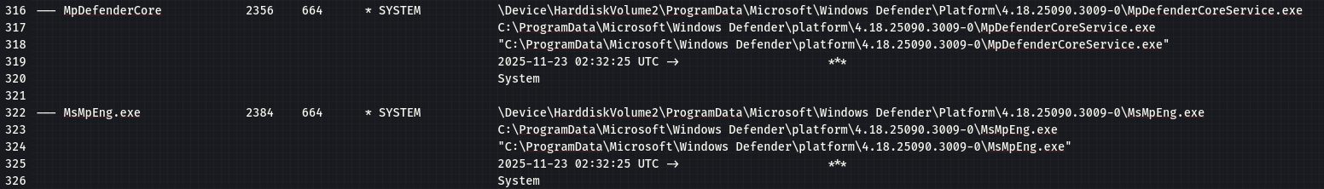 Figure 19 Microsoft defender and anti-malware service present

Pc-491 potentially starting an initial compromise of a machine on network
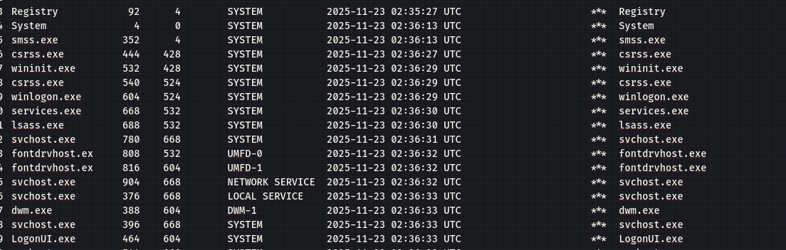 Figure 20 lsass executable and LogonUI.
Figure 21 Spoofing attempt at opening processes ran

Highlights on Network connections(Appendix B for more):
Desktop500-
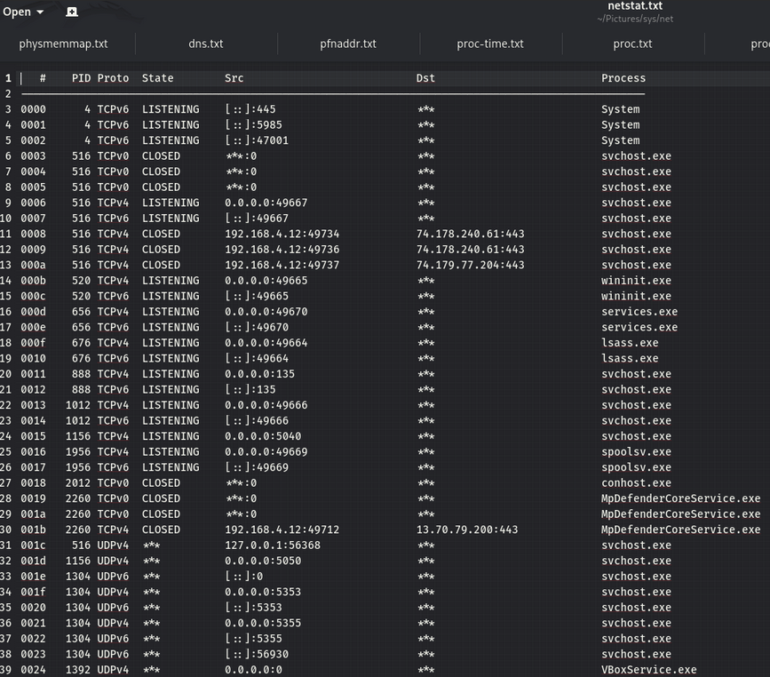
Figure21 Desktop suspicious communicating to foreign addresses
PC-491
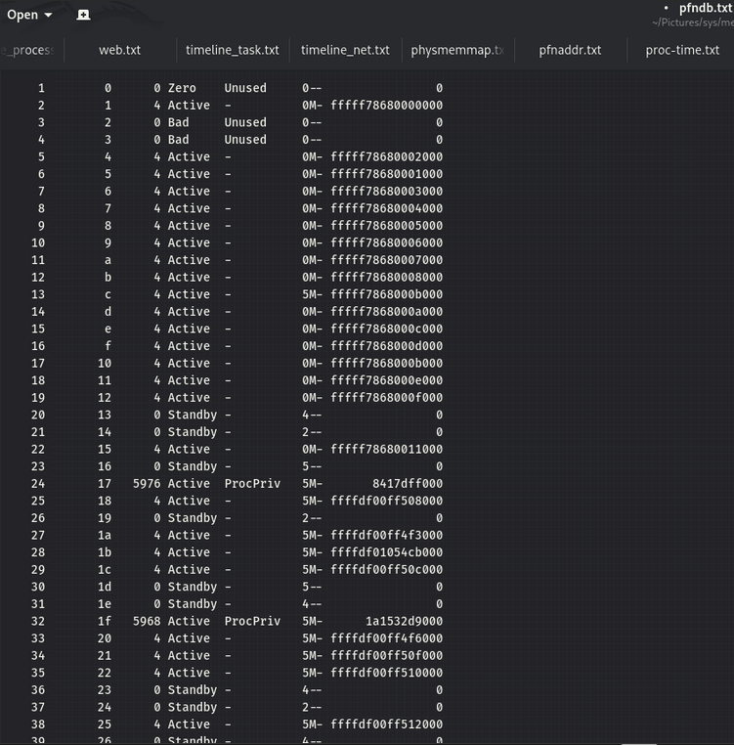
Figure 22 Direct communication to other devices on the network inlcudig foreign addresses.

Workstation-758
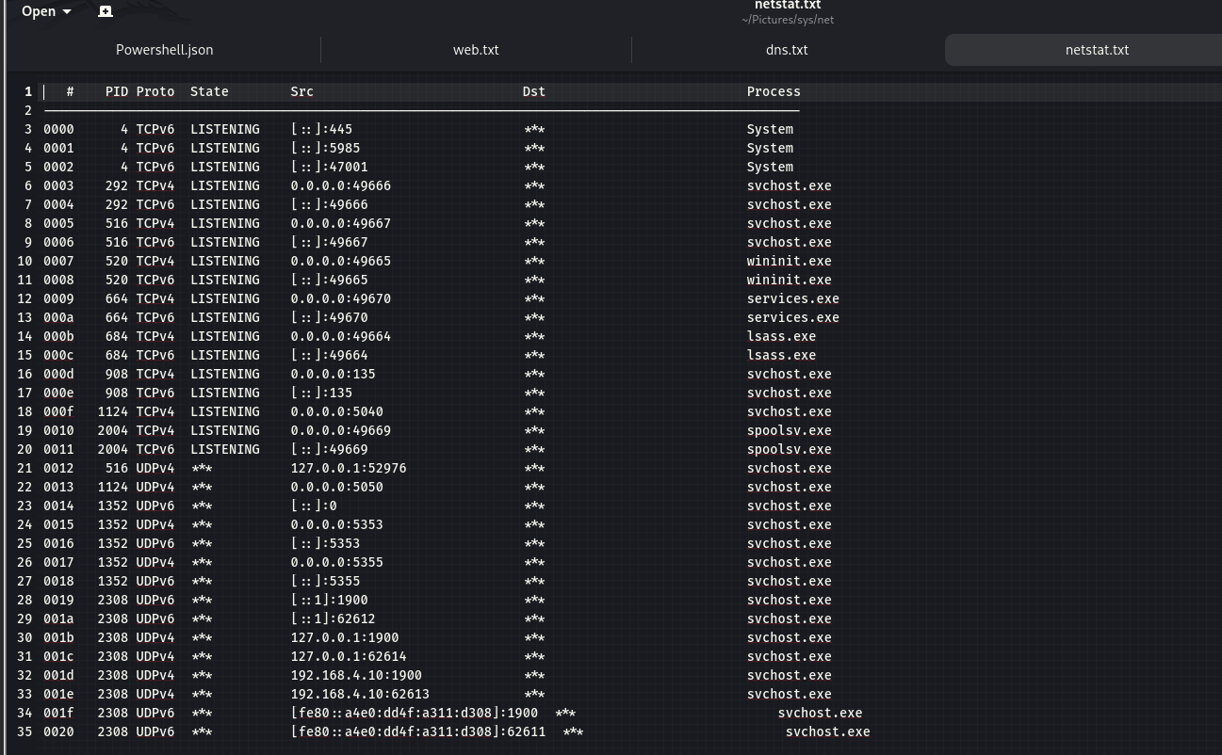
Figure 23 TCPV4 connections, lssas executable being through listening ports

Laptop-142
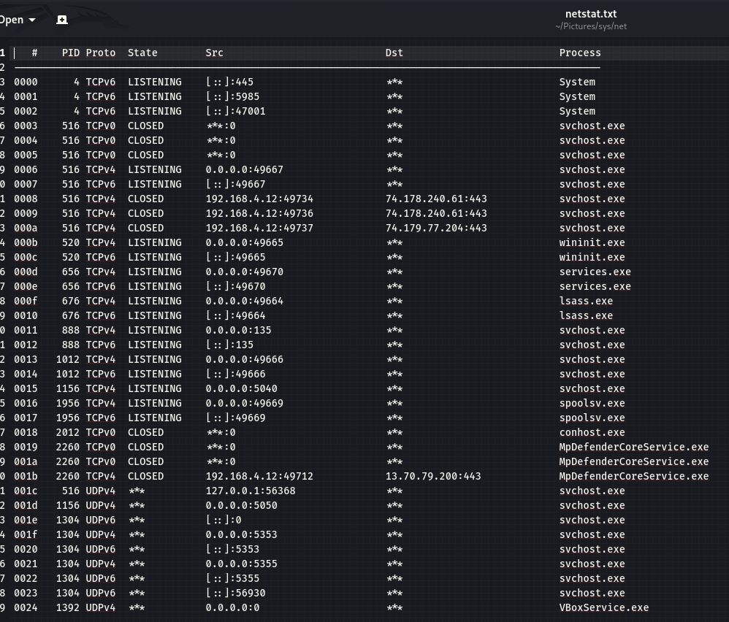
Figure 24 Attempted connections to foreign addresses closed

Step2.7 Check for injected code attempts using Volatility 3 framework using the command “windows.malfind” for all the devices on the network.
Desktop code injection
Figure 25 windows.malfind command
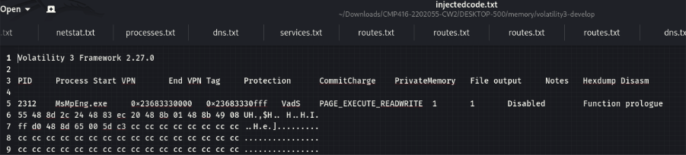
Figure 26 MsMpEng appearing regularly to defend code injection

Workstation code injection
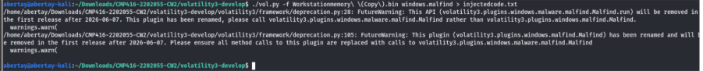

Figure 27 windows.malfind command
Figure 28 MsMpEng identfiying workstation being victime to code injection

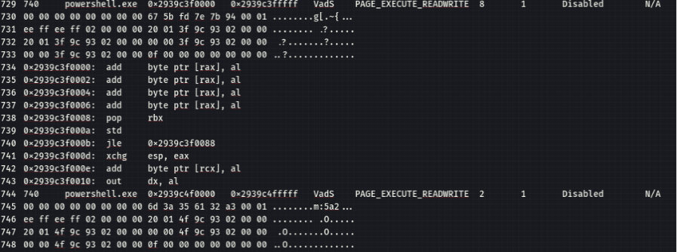
Figure 29 Repeated powershell attempts being evident in the workstation

PC-491 code injection
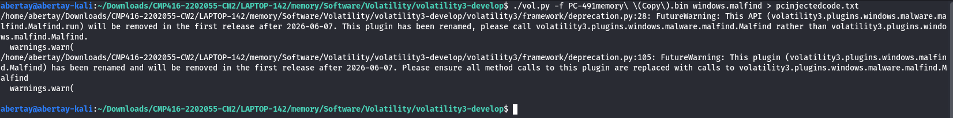 Figure 30 Pc code injection command
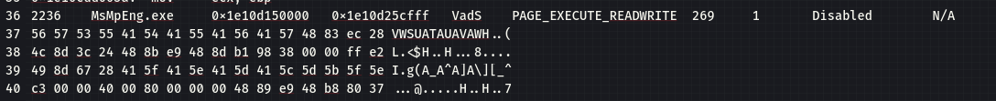 Figure 31 Code injection attempt blocked through defender

Laptop code injection
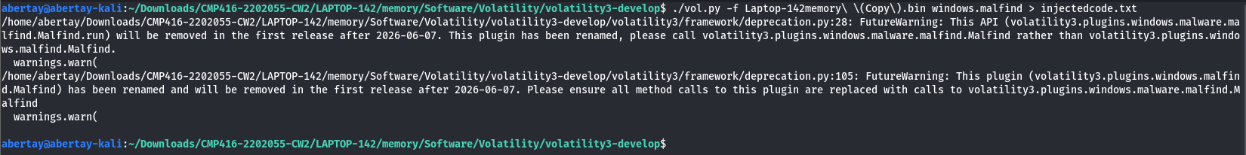 Figure 32 Laptop Code injection
Figure 33 Code injection attempt blocked by defender

Results-Overall for the memory dump running processes part of the analysis, little differences where noted within the devices,however it can still be said that MemprocFS was as a sufficient tool for checking running processes finding spoofing attempts.However for the checking injected code part of the memory dump analysis, Volatility3 was an excellent option to use, the main highlights showing windows defender being tested repeatedly with malicious code injection attempts in all devices but specifically the Workstation-758. Other exe’s where noticeable like “powershell” and “ngentasks” which had been picked up by Volatility3’s malicious code injection scanning feature. Finally the network connections where analysed by MemProcFS, the tool was more than sufficient for this section of the analysis, MemprocFS found high communications on the network listening from unusual ports.

Step3.1 Download the latest edition of evtx parser(omarbenaram,2025) and drag this in to the virtual machine, drag this parser in to every folder that has the system logs.
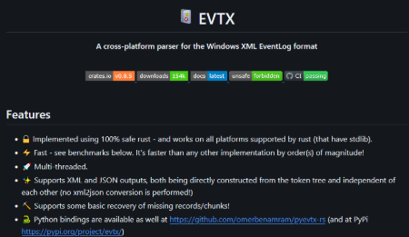

Figure 34 Evtx summary

Step2.2 Put the evtx parser in to the specified directory's per device as seen below
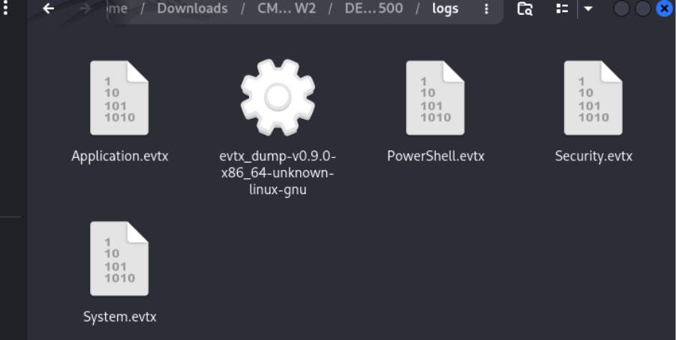

Figure 35 .Evtx files before transmission to JSON

Step3.3 Use the etvx parser to change the logs to JSON files so they can be opened and investigated, repeat this for all devices.
Figure36 Evtx command line for accessible JSON files
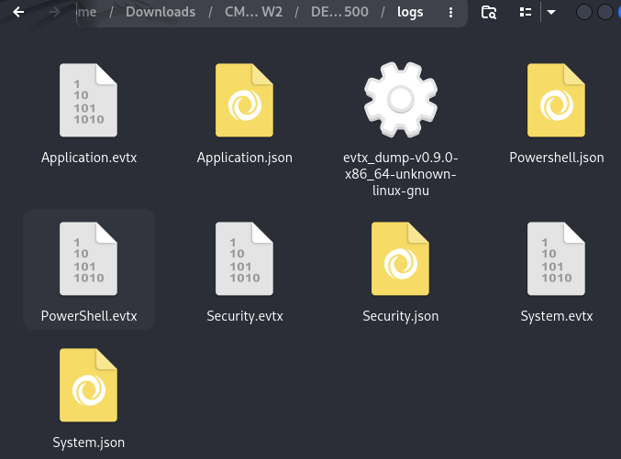
Figure 37 All evtx files now readable in JSON

Step3.4 View Powershell and Security.JSON files for the Desktop device.
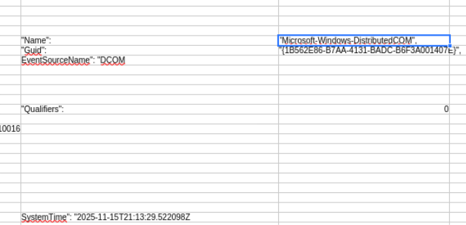

Figure 38 Distributed communication at 21:13:29

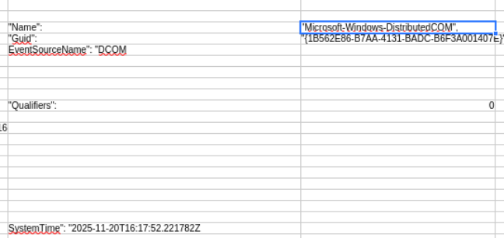

Figure 39 Last communication from Desktop 500

Step3.5 Repeat the same steps for each of the other devices on the network, timestamps are crucial for the timeline.
Laptop logs
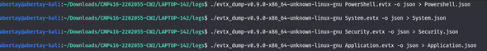 Figure 40 .evtx to .JSON command
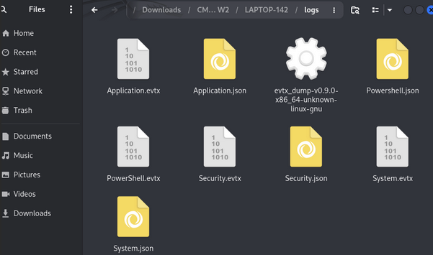
Figure 41 JSON files to view

Figure 42 First record of malware 00:12:21

PC-491 Logs
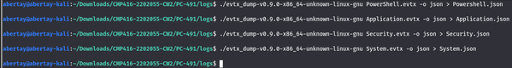
Figure 43 .Evtx to json command
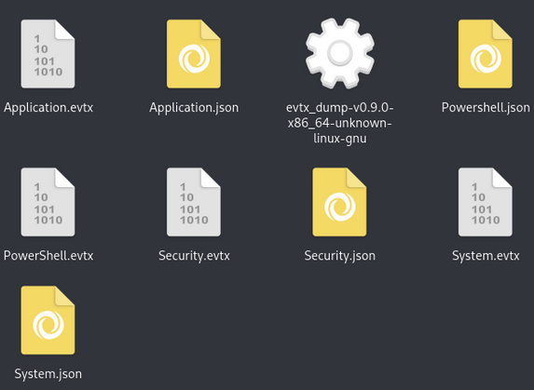
Figure 44 JSON files to view
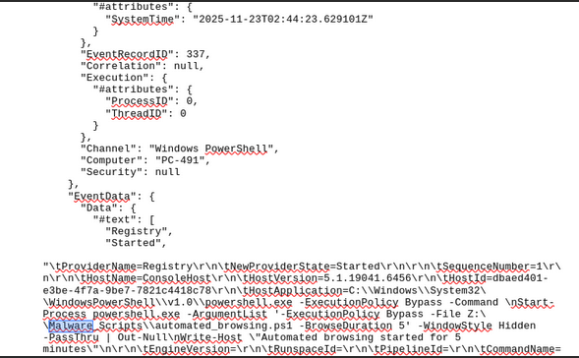

Figure 45 Another malware script named automated_browsing.ps1

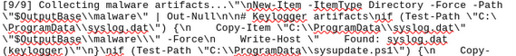

Figure 46 Keylogger deployed again at 02:52:06

Workstation logs
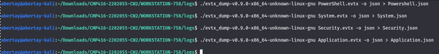

Figure 47 Evtx turned in to JSONs
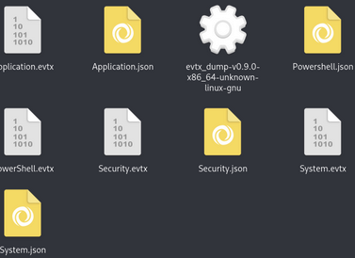

Figure 48 Viewable JSONS in Linux environment

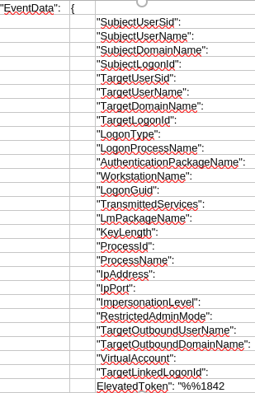

Figure 49 Workstation advanced privilege record

Figure 50 First record of malware(credential_stealer)at 21:23:28

Figure 51 Ransom text file found, possible harvesting to setup demand for ransom

Figure 52 Last record of malware in the workstation PowerShell log 22:11:06
Step3.6 Check the workstation folder for any credentials found as they are mentioned in the workstation system logs.
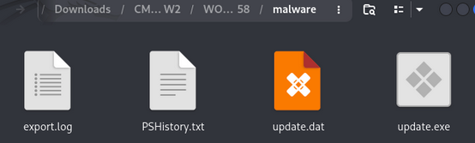
Figure 53 Malware executable and export log found
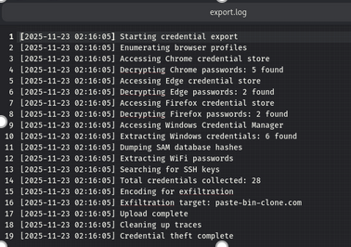

Figure 54 Log of what the malware is targeting and harvesting
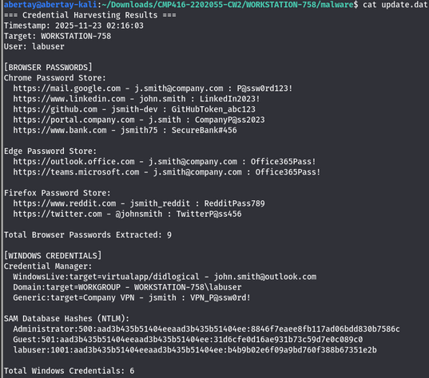

Figure54 A complete directory of what the malware has carved out from the victim workstation

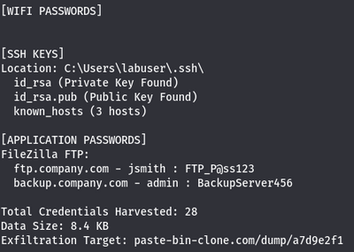

Figure 55 28 credentials harvested
Results- Overall, evtx parser was absolutely critical to finding out the most important information to the report investigation. The tool has allowed the evtx windows style format to be read in a Linux environment with the main highlights being finding where the credentials being harvested from are being kept, how much had been taken from the victim and malware spreading round machines on the network at different times.

Step3.7 Starting with the Workstation machine go through every device’s browser history to explore if the keylogger was present when on these URL’s.
Workstation
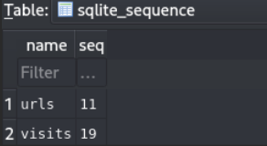
Figure 56 Number of urls visited is 11
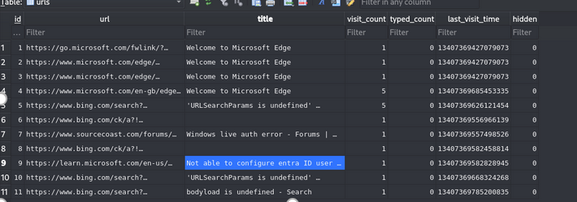

Figure 57 Highlighted is an attempt to create credentials

PC-491
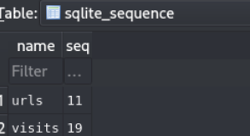

Figure 58 Number of urls is the same
Figure 59 PC-491 had an authentication denied for bing.com(potential attacker)

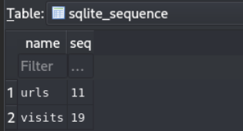
Desktop-500

Figure 60 URLS quantity is the same for all devices.
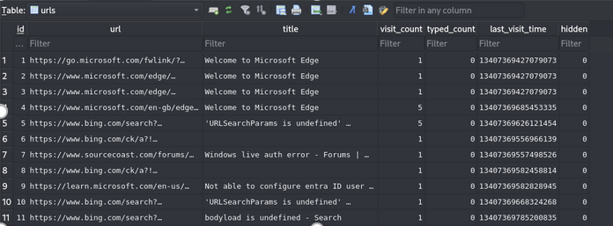

Figure 61 A live windows authentication error PC-491

Laptop-142
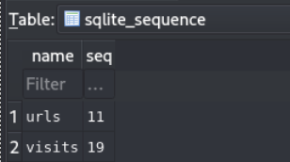

Figure 62 URL’s visited is the same as other devices

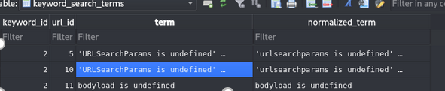

Figure 63 User has entered an undefined parameter potential forced browsing

Indicators Of Compromise(IOC)
Step4.1 Go over the .pcap file for any transactions or communication during the recently discovered times of PowerShell previously identified in the system logs for Workstation and PC-491.
Figure 64 PC-491 transaction minutes before the last malware ps.1 finished executing
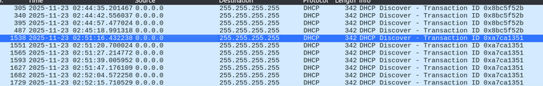 Figure 65 Filtering the PC-491, All DCHP transactions are to the same destination

Step4.2 In wireshark,click on “statistics -> converstations” then ipv4 to view the packets being sent round the network to highlight spikes in heavy traffic.

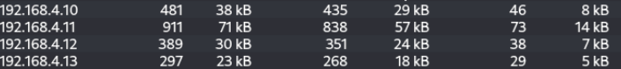 Figure 66 PC-491 regularly had biggest spike in traffic amount of packet bytes(911kb)

Figure 67 PC-491 direct conversation with another device sending constant high traffic.

Step4.3 Check the system logs for any output “beconing” to another device.
Figure 67 Workstation Powershell.json log

Figures 68 PC-491 beacon log that is also attached to workstation the victim.

Results- From the indicators of compromise Wireshark was an excellent tool to identify out of the ordinary network traffic between the proposed victim and attacker. There has been clear transactions from one device to another seen in Figure65.Evtx again allowed the system logs of both PC-491(attacker) and Workstation-758(victim), after searching through records for malware beaconing in Figure 67 and 68 is an identified “becon.log” meaning their is a constant direct link to Workstation-758 being compromised and connected by this beacon from PC-491 showing intent to disrupt or damage.

Interpret and report findings

Timeline of events & affected devices

Network infected movement Diagram
PC-491 -> LAPTOP-142->Desktop-500-> Workstation-758
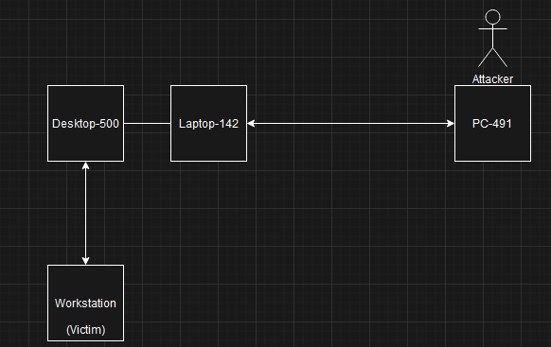
(Draw.io,Unknown)

How the malware spread
The malware was spread initially by a spoofing attempt from PC-491 to devices on the network. The behaviour intended by the attacker was to disrupt by getting users on their devices to fall victim to altering the harmful software to act as a trusted local device on the network. This bypasses the firewall by the evading technique and once one device is compromised all devices on the network are at risk.

The attempts where coming from PC-491 and started making its way hopping from Laptop-491 to Desktop-500 to then harvest credentials from Workstation-758 .The spoofing attempt is a perfect initial compromise to leading to further damages, in this case a keylogger intended to wait until devices start logging in to company and private websites seen through the DNS query’s in the early stage of the report. Once these keyloggers store this information and start beaconing them out to an output file it can cause irreversible damage. The malware was set to carve and set up for demanding ransom seen from later in the analysis having a file created called “ransom.txt”.

Initial compromise to end of payload execution
Machine | Initial compromise | Execution Ended
Desktop-500 | 22:12:40 | 22::27:23
PC-491 | 02:44:23 | 02::52:06
Workstation-758 | 21:29:29 | 22:20:04
Laptop-142 | 00:12:05 | 00:21:44

Challenges during analysis
Unable to locate effective information regarding the firewall:
There was many attempts to gain knowledge of the firewall logs, however even with the usage of MemProcFS no logs on the firewall where gained. This hurt the investigation by not permitting the ability to see either unauthorized access possibly through a foreign address or suspicious activity outside of the firewall. These directory’s or files may have give the investigation a better overall coverage of intent to distribute or cause malicious activity within the internal network.

Browser history lack of information:
Due to the nature of the malware accessing the users url browsing on the device, all information regarding the results of the browser logs had been similar if not identical. There was a authentication attempts on the browser history possibly leading to unauthorised accessed to users account.However, for all devices the browser history failed to give the investigation sufficient information regarding the connections from urls visitred to information retrieved.

Recommendations

Remediation and prevention plan
The university should employ should be a NIDS(Network intrusion detection system) this time with a inside internal firewall placed more effectively on the network. The benefits of installing one of these in this position is that the network is that the firewall is able to detect outgoing and incoming attacks specifically protecting the devices on the internal network meaning internal sabotage would me remediated. The NIDS system detects the threat and mitigates the issue rather than detecting the threat and resulting to a set-configured response, the configuration for one of these systems can be filled out with specifics on ports to use and known baselines of network traffic and behaviors that way any abnormalities should trigger an alter and the NIDS should come in to place effectively.

Further forward the university should also revise their current firewall configuration within their internal network, this investigation shown that devices where not only able to have communication with foreign addresses but also able to transfer outside traffic in to the network.An alternative HIDPS(host based intrusion detection/prevention system). This allows networks to be constantly monitoring events and report and alter when suspicious activity occurs well before any sort of harmful activity can be attempted.

Finally the university should consider gathering hierarchy to go over new user awareness training for threats on the network to all staff members regardless of technical ability, if staff are aware of these threats and know how to prevent or report them effectively this can help mitigate the issue. Malware is a constant threat with new strains and evading techniques being built, an effective solution is constantly being accepting advice from governing bodies. The documents from NCSC(NCSC,2020)gives current advice on how public and private organisations can keep safe from malicious activity. The advice covers all relevant information on how to stay protected.

References

(ACPO guidelines & principles explained | Forensic Control, no date)
Available from:https://forensiccontrol.com/guides/acpo-guidelines-principles-explained/
[Accessed 9 December 2025]
https://github.com/omerbenamram/evtx
[Created May 14 2019] Accessed[25th November 2025]
Vincze, E.A., 2016. Challenges in digital forensics. Police Practice and Research, 17(2), pp.183-194.
https://www.wireshark.org/download.html
[Created Unknown ][Accessed 22nd November 2025]
https://github.com/volatilityfoundation/volatility3
[Created September 25][Accessed 22nd November 2025]
https://github.com/ufrisk/MemProcFS/releases/tag/v5.16
[Latest version October 5th][Accessed 22nd November 2025]
https://www.ncsc.gov.uk/guidance/mitigating-malware-and-ransomware-attacks
[Created 13th Feburary 2020] [Accessed 20th December 2025]
https://www.brookes.ac.uk/students/academic-development/online-resources/executive-summary
[Created Unknown][Accessed 21st December 2025]
https://www.nist.gov/document/sample-chain-custody-formdocx
[Created Unknown][Accessed 15th November 2025]
https://www.draw.io/
[Created Unknown] [Accessed 18th December 2025]

Appendices
Note that Appendices should be referenced in the main body of the text.

Appendix A
MemprocFS running processes

Desktop-500
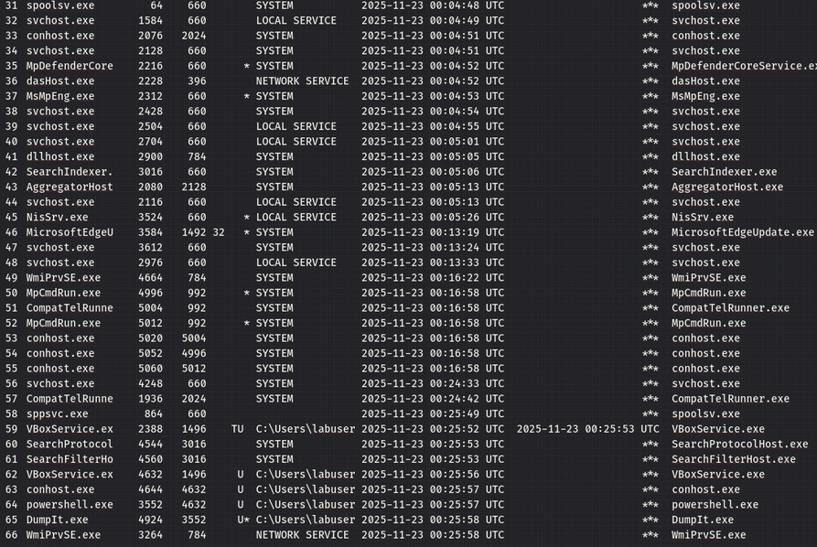

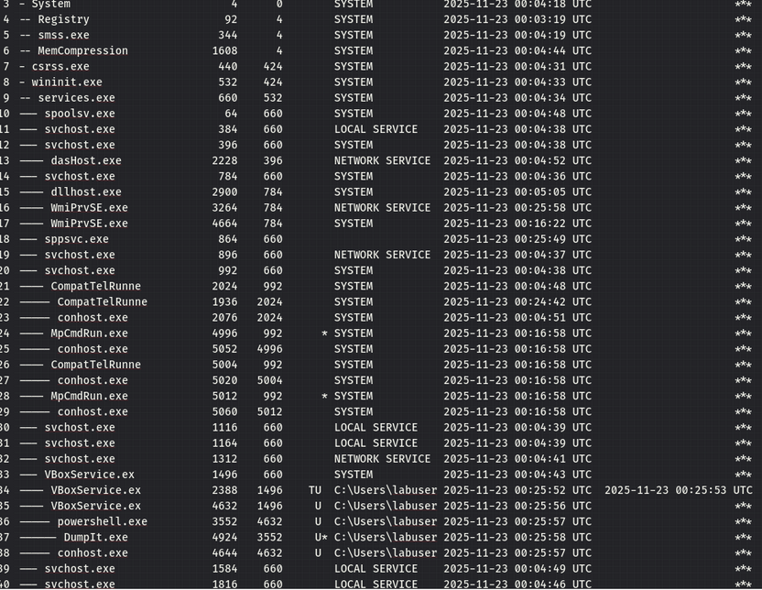

Laptop-142
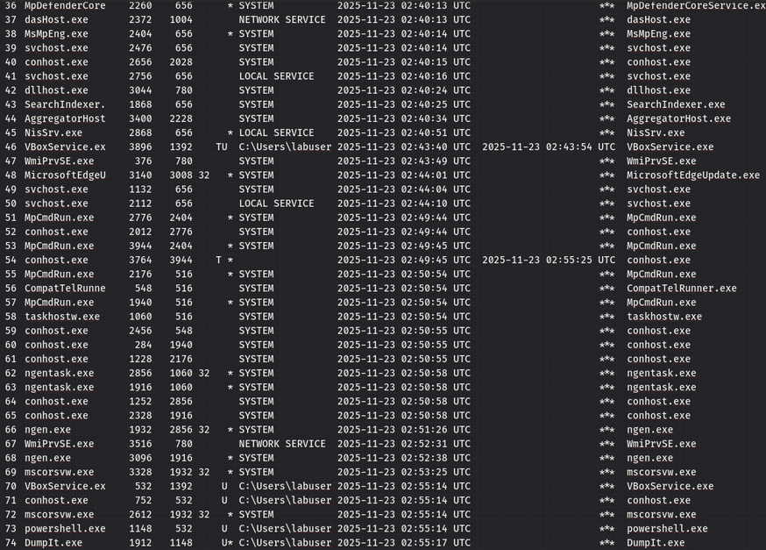

Appendix B
